Multiple_year_stock_data:

2016 Results screenshot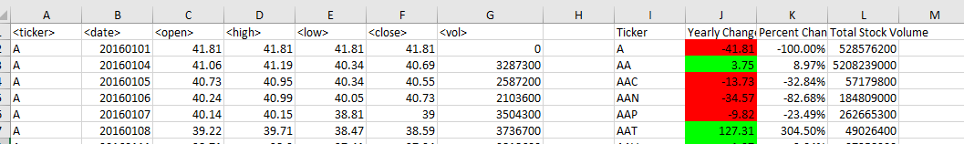

2015 Results screenshot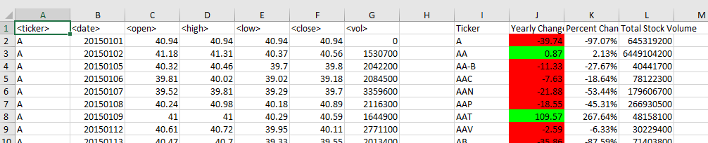

2014 Results screenshot

